Practical - 8
Practical Title: 8: MySQL Schema Design, ER Model, PDO Connectivity, and Prepared Statements

Problem Definition: Design the database for StudentHub with students, events and

registrations. Create PHP database connection using MYSQL statements.

Theory

1. Is the schema normalized properly?
ANSWER: Yes, the database schema should be normalized to reduce data redundancy, avoid data anomalies, and maintain data consistency.
Normalization is the process of organizing data into related tables to avoid unnecessary duplication.
For example, instead of storing a student's name and email repeatedly for every event, we store the student's details once in the students table and refer to that student through their ID.

2. Are primary keys and foreign keys correctly defined?
ANSWER: Yes, primary keys and foreign keys are correctly defined. They should be defined to uniquely identify records and maintain relationships between tables.

3. Is the database connection handled securely?
ANSWER: Yes, it is handled securely. The database connection should be handled securely using prepared statements, proper error handling, and secure credential management.
- Prepared statements: These separate SQL instructions from user-supplied values, helping prevent SQL injection.
- Exception handling: Database errors can be caught and handled without exposing sensitive details to users.
- Credential security: Database credentials should not be exposed in publicly accessible files or source repositories.
- Input validation: Validate user input according to the expected type, length, and format.

Implementation/ Output/Result:

Evidence of Work (Screenshots):
Certificate:
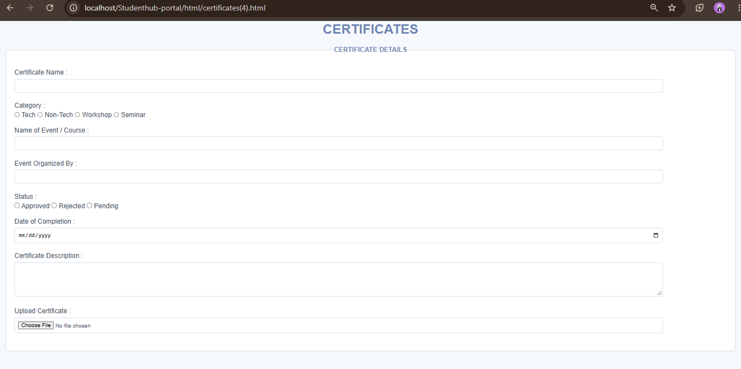

Entering details:
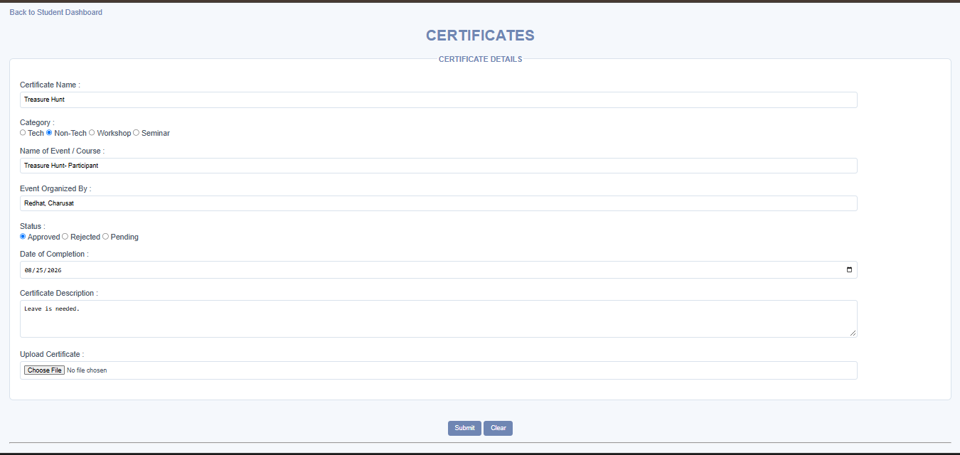
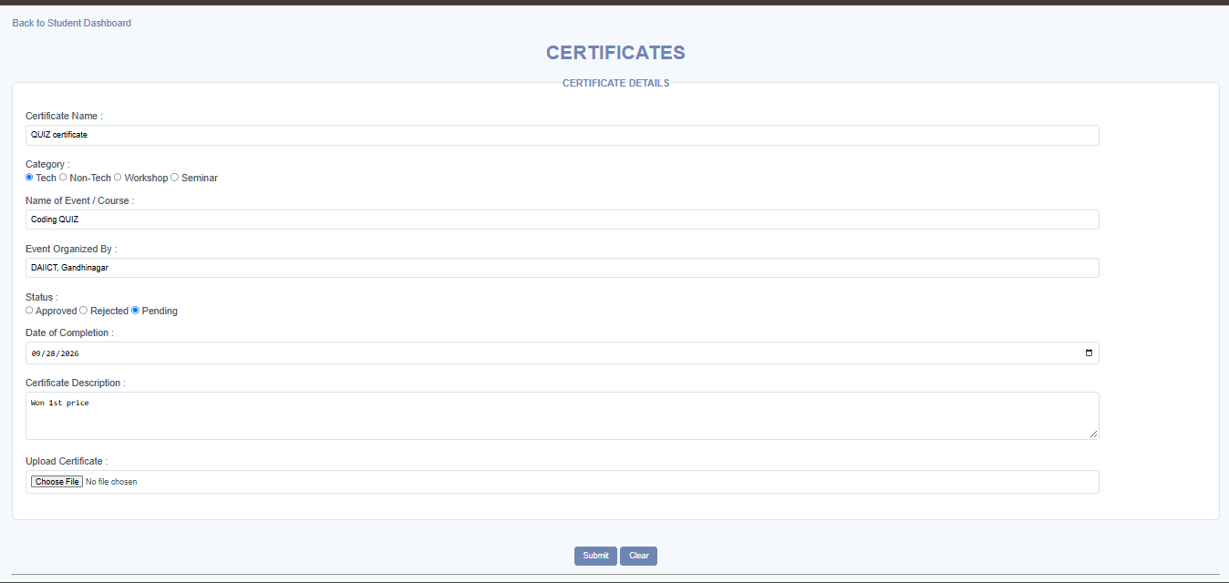

Successfully details saved:
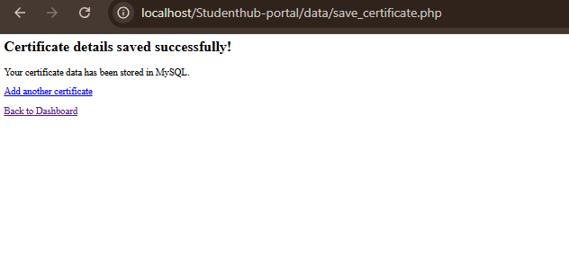

Database:
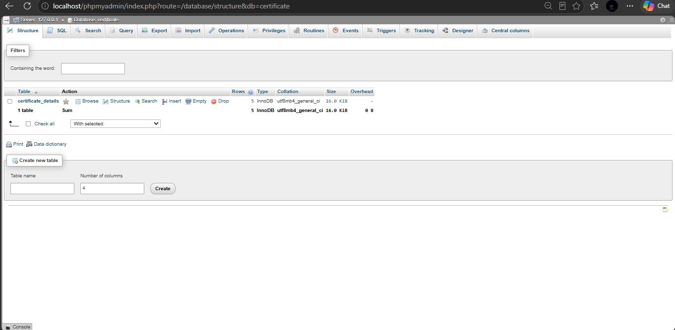

MYSQL:
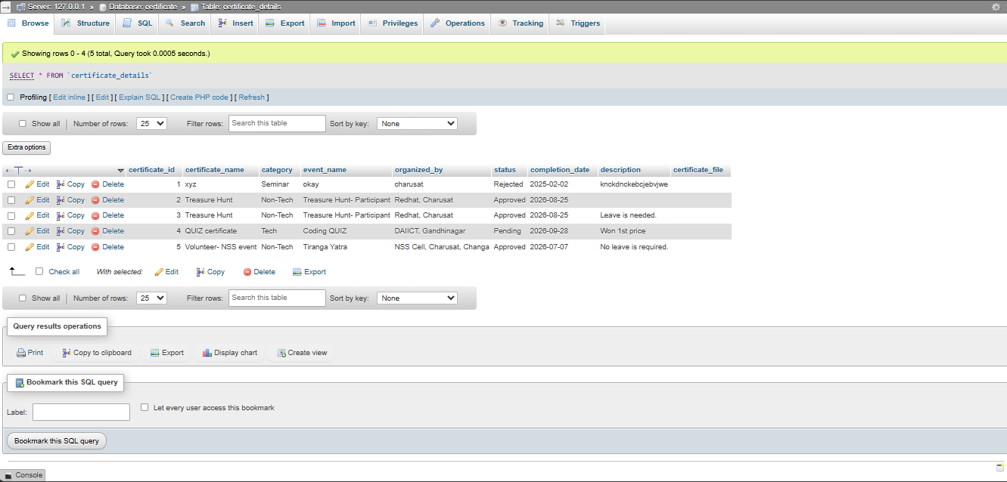

GitHub Repository Link:

https://github.com/shiloni28/WDF.git

E.Challenges Faced:

- Establishing a successful connection between PHP and the MySQL database.
- Ensuring that the database and table names matched those used in the PHP code.
- Defining appropriate primary keys, foreign keys, and relationships between database tables.
- Using prepared statements correctly to insert data into MySQL.
- Validating form inputs and handling missing or invalid values.
- Identifying and resolving database connection and query execution errors.

F.Learning Outcomes:

- Learned to design and create a MySQL database using phpMyAdmin.
- Learned to define primary keys and foreign keys to maintain data integrity.
- Learned to establish a connection between PHP and MySQL using MySQLi.
- Understood the use of prepared statements for secure SQL query execution.
- Learned to validate user inputs before inserting data into the database.
- Gained experience in handling database connection errors and SQL query errors.
- Understood how database-backed web applications store and manage data securely.
- Gained practical experience using XAMPP to run and test PHP–MySQL applications.

Faculty Remarks:

